1. **Dependency**: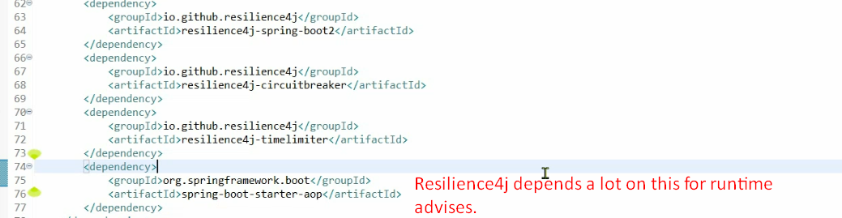
2. @CircuitBreaker